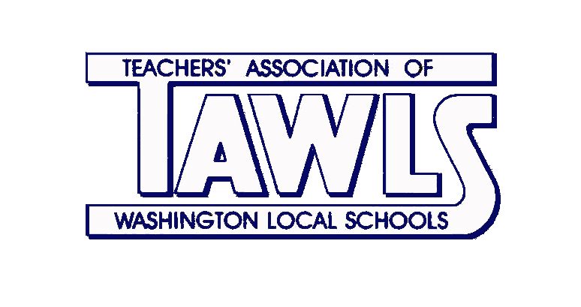
April Committee Reports
Activities  Emily Schifko | - This Friday, April 17th is our TAWLS event at the Mud Hens renamed “Terry Time at the Mud Hens.”  - In addition to festivities this year, an added basket raffle is going to take place with proceeds benefiting the Zielinski-Terry Science Scholarship fund.  - There are currently 90 attendees with at least 10 children. This is an increase from the 28 who attended last year.  - Moving forward to next year, TAWLS is looking into having a chairperson for each activity planned for the 2015-2016 school year.  - Activities are intended to make our association stronger and bring people together in the buildings as well as across the district.
Audit & Budget  Rhea Young | - The February and March Treasurer’s reports will be presented.  - After Prom committee is seeking a donation from TAWLS.
Awards  Heather Densmore | - Outstanding Teacher Award: Kathy Chaka and Matt Kizaur.  - Outstanding Educator will be awarded posthumously to Jim Terry.  - Applications for the Golden Apple will be accepted until April 30th.
Banquet  Joy Krajewski | - The banquet is set for April 23rd. The hall will be open the day before to prepare it for the banquet. In addition to the sixteen retirees, we will have three award winners and a special presentation in honor of Jim Terry.
Calendar  Paula Giovanoli | - No report
Committee to Elect  Matt Durham | - Committee will be meeting to prepare questionnaires for school board candidates to be used during next year’s school board elections.  - Committee is also looking at holding a forum for board candidates.  - Committee will potentially form a PAC to support our local candidates.
EDI  Jason Schreiner | - The creation of a fourth Dean at Whitmer will use funds from a retiring librarian to pay for this position.  - This new EDI positions was suggested by administration.
Elections  Jen Mayo | - By acclamation, Jen Gent, Rhea Young, and Christopher Hodnicki were elected to serve as delegates to NEA RA this summer in Orlando, Florida.
Grievance  Jim Terry | - No report
HCC  Linda Markowiak | - No report
Historian  Melissa Hieronimus | - Please send pictures to Melissa Hieronimus and Dana Edmonds who uploads them to the TAWLS website at tawls.ohea.us or under links on the WLS Teamwork page.
Human Relations  Jen Gent/Wendy McCall | - No report
Legislative (FCPE)  Julie Hogan | - No report
LPDC  Lori Bosch/John Mohn/Mari Tate | - Remember to get your paperwork in if you need to renew your license.
New Teacher  Michelle Hetzel  Kristin McCorkle | - Gifts cards were purchased for the new teachers and will be presented at the TAWLS banquet.
Policy  Jim Terry | - No report
Scholarship  Dana Edmonds  Heidi Hartman | - Friday, April 17th is the deadline for students to turn in the applications for scholarships.  - Members are encouraged to continue to support the TAWLS Employee Scholarship Fund

