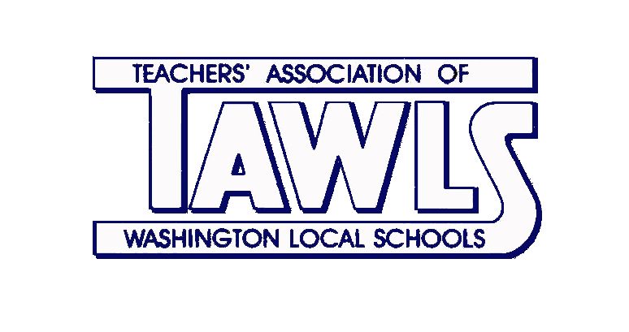
Committee Reports
Activities
Emily Schifko
Audit & Budget
Rhea Young
Awards
Heather Densmore
Banquet
Joy Krajewski
Calendar
Paula Giovanoli
Committee to Elect
Matt Durham
EDI
Jason Schreiner
Elections
Jen Mayo
Grievance
Karen Herrera
HCC
Linda Markowiak
Historian
Melissa Hieronimus
Human Relations
Jen Gent/Wendy McCall
Legislative (FCPE)
Julie Hogan
LPDC
Lori Bosch/John Mohn/Mari Tate
New Teacher
Michelle Hetzel
Kristin McCorkle
Policy
Jim Terry
Scholarship
Dana Edmonds
Heidi Hartman

