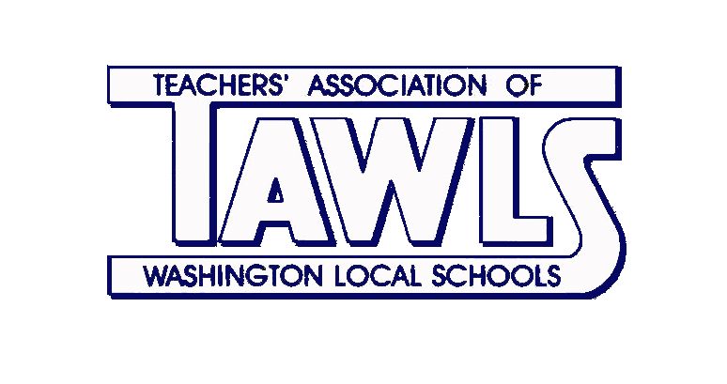
MR. CHRISTOPHER HODNICKI, M.Ed.

President, Teachers’ Association of Washington Local Schools
TAWLS Office – Whitmer High School
#419-473-8383 EXT 8345

“Working together for our kids”

UNITY, INTEGRITY, PROFESSIONALISM

WELCOME BACK TAWLS MEMBERS! September 5, 2015
After a restful and revitalizing summer break, the start of each school year is always the perfect time to engage new ideas and embrace new opportunities. Doing so, requires enthusiasm, passion, and commitment. Your embodiment of those ideals remains a role model for inspiring each other and our students. Our efforts and actions challenge each other daily to become better learners in order to step forward and make a difference.
Our ideals of unity, integrity, and professionalism have never been as strong as in this upcoming school year. Not only have we experienced the agony of legislation from Columbus, the changes in OTES, SLOs, new standardized testing, but we face another school board election and a year to negotiate our contract. We have all watched the humiliation of public educators from Strongsville to Youngstown, as legislators and school boards have sought to eliminate the integrity of teaching. We are fortunate that there has always been strong respect and collaboration between TAWLS, the Administration, and the school board. Keeping that relationship strong, successful, and for the betterment of our community, it is imperative to support David Hunter, Eric Kiser, and Lisa Canales.
Even with victory, that does not mean we should be complacent. Continue to be active with TAWLS by standing together and working cooperatively with other teachers will help us maintain our professionalism and integrity. It is also your duty as an educator to call attention to injustices or remarks by being assertive yet professional. It is collectively through our voices that we can improve education.
As we advance through the school year, remember that we are a professional association here to listen, support, and advocate for you. We will always listen to your concerns, ideas, recommendations, and suggestions for assistance, professional development, and help to enhance your achievements. We will continue to support and celebrate your successes in the classroom and the work you do in the district, while always continuing to advocate for your rights and fair treatment as a professional, because you have earned it. Let us remain strong and united to work together for our kids and our district to make this a great year!
Mr. Christopher Hodnicki
TAWLS President

